Title: Day 6 – IoT Smart Home Dashboard

Date: 16 Sept 2025
Name: Nihar Ashraf

Introduction:
On Day 6, we focused on extending the IoT Smart Home Dashboard with telemetry tracking.
Until Day 5, our system could register devices, change statuses, and update MySQL, but there was no historical record of when devices were switched ON or OFF and by whom.
To solve this, we integrated DynamoDB (NoSQL Local Workbench) to store telemetry events. This allows us to keep a time-series log of all device activities, including timestamps, owner IDs, and status changes.

Activities Done:
- Created Telemetry Table in DynamoDB Local
- Table name: Telemetry
- Partition key: device_id (String)
- Sort key: ts (String – ISO UTC timestamp).
- Additional attributes: metric, value, owner_id, ts_local.

- TelemetryRecord Class
- Captures deviceId, metric, value, ownerId, and ts.
- Generates both ts (ISO 8601 UTC) and ts_local (human-readable local timestamp

- TelemetryDAO Implementation
- Connected to DynamoDB Local at http://localhost:8000.
- Added putTelemetry(...) method to insert records into the Telemetry table.
- Handles failures gracefully (logs errors without stopping app).

- UpdateGadgetStatus Integration
- After a device’s status is changed:
- MySQL (gadgets table) is updated.
- A telemetry record is written into DynamoDB.
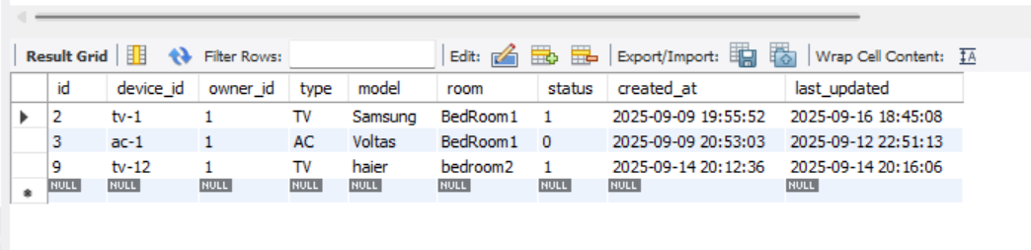
- Fixed Timestamp Readability
- Initially stored only epoch milliseconds (hard to read).
- Updated to include ts_local so developers and users can read logs in YYYY-MM-DD HH:mm:ss format.
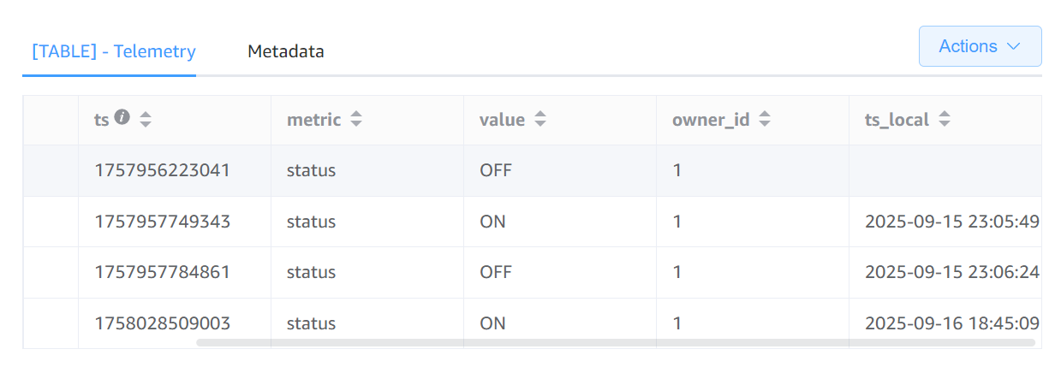

Improvements Achieved:
- IoT system now supports dual databases:
  - MySQL → canonical device state.
  - DynamoDB → historical telemetry logs.
- Full visibility of when, what, and by whom each action happened.
- Improved timestamp storage: both machine-readable (ts) and human-friendly (ts_local).
- System prepared for analytics, reporting, and visualization.
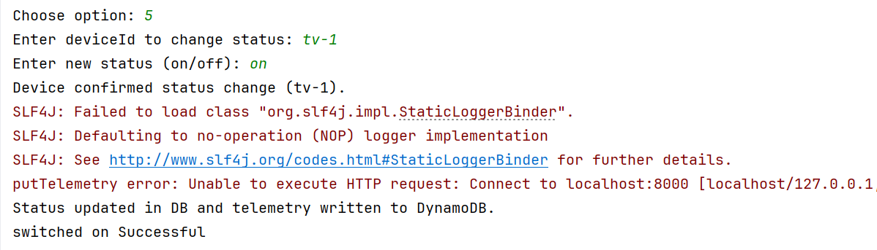
Issues Faced & Fixes:
- Type mismatch error → solved by storing ts as String (ISO).
- CustomerId vs OwnerId confusion → aligned with ownerId.
- Unreadable timestamps → fixed by adding ts_local.
- Maven dependency issues → fixed by using AWS SDK v2 DynamoDB.
Conclusion:
- Day 6 successfully introduced telemetry tracking to the IoT Dashboard.
- Now every device action is logged with detailed timestamps and ownership information.
- This lays the foundation for future features like analytics, alerting, and visualization.

